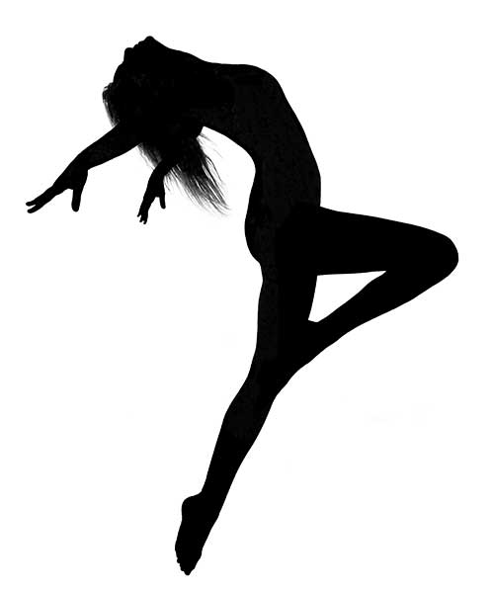**Dunsmuir Dance Academy 2017/18**

**“Eat. Sleep. Breathe. *Dance*!”**

**What is the Dunsmuir Dance Academy?**

The Dunsmuir Dance Academy is a multi-style dance skill development program offered

at Dunsmuir Middle School for students in grades 6, 7 and 8. It is currently in its 9th year of

operation and is instructed by Danica Anderson.

**About the Instructor**

*Danica* is a teacher with dance training in ballet, pointe, jazz, contemporary, tap, lyrical, musical theatre and modern dance. She is also a competitive Figure Skater and Gold level Ice Dancer with the Juan de Fuca Figure Skating Club. She was a long-time performer/choreographer with P.A.C.E. Musical Theatre and is also a triple-threat graduate from the prestigious *Canadian College of Performing Arts*, where she studied with dance teachers including David Roland, Janice Tooby-MacDonald, Sherri Black and Jacques Lemay. She has directed/choreographed full length musicals including, “Annie”, “Little Shop of Horrors”, and “Joseph and the Amazing Technicolor Dreamcoat”. Locally, Danica has studied and performed with Karen Clark Dance Studio, Wendy Steen Mitchell Dance, Dansko and Broadstreet Dance.

**Who can apply for the Dance Academy?**

The Dunsmuir Dance Academy is open to any interested students in grades 6-8 who possess a passion and enthusiasm for dance along with a high level of commitment and coachibility required to improve & expand upon their existing dance training. Although the program is not reserved for students with prior studio dance training, any recent experience in dance or other dance-related sports (gymnastics/figure skating) is beneficial. We do, however, welcome dancers at all skill levels as the program is designed to offer experience and training in multiple dance styles with an emphasis on individual improvement and development as both a dancer and performer. Eligible students must: be physically capable of the demands of regular dance and fitness training, demonstrate excellent attendance, be available for all performances, be motivated to practice outside of class, be able to balance the demands of the Academy with personal life and other sports/outside activities as well as academic success, and cope well under pressure and in front of an audience.

**How does this program “fit” into the student’s daily schedule?**

This program is offered within the regular school day. Students attend dance class in the Dunsmuir Dance Studio. ***For the 2017/18 school year, students will have dance classes 3 times/week. They will not take P.E.***

**What kind of instruction will the dancers receive?**

Dancers will be offered instruction in many different styles of dance throughout the year. Regular classes will consist of extensive warm-up routines, strength & flexibility training, conditioning, cross-floor skill development, choreography, as well as student created choreography and teaching experience. Some of the dance genres covered in Academy will include Jazz, Ballet, Contemporary, and Tap (as well as Hip Hop at the grade 8 level). Along with regular weekly dance instruction, dancers will participate in monthly dance workshops taught by guest teachers, they will train with 2 resident choreographers, and attend presentations/performances by local professional dance companies. Dancers will also perform both in the school and out in the community, including the *Greater Victoria Performing Arts Festival* as well as Dunsmuir’s “*Evening of Dance”* year-end recital.

**What Supplies will dancers need?**

All dancers will need school-appropriate, fitted dance attire, black tap shoes (which can be rented from our studio), black jazz shoes, nude foot undeez (optional), water bottle (supplied to all new dancers in the program), dance performance undergarments, and Academy Uniforms (provided as part of the dancer kit).

**Dance Shoes and clothing can be purchased at:**

Ellswear Dance: 3180 Harriet Rd.

Toes n’ Taps Dance Shoppe: 1733 Cook St.

**What are the Program Fees ?**

Fees for the 2017/18 school year will be approximately $940.00 with an $85.00 deposit due at the time of registration. Fees will cover:

* All dance instruction
* Dancer Kit (includes Academy uniform, dance bag)
* Resident Choreographers
* Festival Fees, admission, and transportation costs
* Workshops and Demonstrations
* All costuming
* Year end recital

**How do I Apply for Dunsmuir’s Dance Academy?**

To register, fill out an application online at <https://registration2016.sd62.bc.ca/apps/academy>. Applications will be accepted starting *Wednesday, Feb.1st at 6:00am.* Acceptance into the Academy is first-come-first-served (applications are time-stamped) but is also based on student responses to the application questions.

The application student questions are listed below. It is best to have students prepare their responses ahead of time so you can simply cut and paste them into your application at the time of registration. Students should be prepared to write a paragraph response on the following questions:

Question #1: In the form of a paragraph, please explain why you feel you would make a good candidate for Dunsmuir’s Dance Academy.

*Sample Student Response*: I would like to attend the Dunsmuir dance academy because I would like to have an opportunity to expand not only my previous knowledge of dance, but to get to expand the styles of dance that I currently participate in. I would also like to be in the dance academy as I wish to meet peers who share the love of dance as I do, and work with them as a strong dancing team.

Question #2: Please describe all relevant experience in dance as well as performance-related sports (ie. Gymnastics/figure skating/cheerleading) and performing arts (music/theatre).

*Sample Student Response*: I have been dancing since I was 2 years old and have been enrolled in the Westcoast Academy of Performing Arts (WAPA) for the last five years. At WAPA I have completed my Grade 1 ballet exam, my Grade 2 ballet exam, my Grade 3 ballet exam, and am currently working on completing my Grade 4 ballet exam with the new RAD syllabus. In modern I have completed my ISTD Grade 3 exam, Grade 4 exam, and am currently working on completing my Grade 5 exam. At WAPA I am also taking Hip Hop and Jazz, both which are non-exam classes.

**How can I find out more about the Dunsmuir Dance Academy?**

* Please visit our website at: www.dunsmuirdanceacademy.weebly.com

* Contact the Dance Academy Director, *Danica Anderson*: [danderson@sd62.bc.ca](mailto:danderson@sd62.bc.ca)

**For more information about registration, fees/payment options, and bursaries:**

Contact Vice Principal of Academies, Wayne Kelly: [wkelly@sd62.bc.ca](mailto:wkelly@sd62.bc.ca)